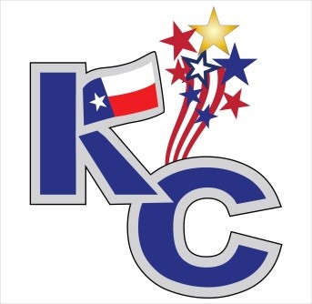
Founder’s Day 2017
Saturday, December 09, 2017
Entertainment Registration Form
Name (or Group Name): _____________________________________________________________
Talent: __________________________________________________________________________
If music, what genre?_______________________________________________________________
When are you available? (please Circle)
Anytime Noon 1:00 1:30 2:00 2:30 3:00 3:30 4:00
What equipment do you provide? _________________________________________________________________________________

Contact Information:
Contact Name: _____________________________________________________________________
Phone: _____________________________________________________________________________
Email:_______________________________________________________________________________

** Entertainment at Founder’s Day 2017 is completely on a volunteer basis. **

If you would like to participate in the event,
please return this form back to our office at
314 E. Calvert Ave. Karnes City, Texas 78118
or fax it to (830) 780-2227.
For more information, give us a call at (830) 780-3422.

